
Jaypee Univeristy of Information Technology, Waknaghat Solan H.P

Solution Sheet
Binomial Heap

Q1)Answer:
1. Binomial Tree
A binomial tree is a recursively defined tree structure used as the basic building block of a binomial heap. It is denoted by B^{k}, where k represents the order of the tree.
Properties of a Binomial Tree
- A binomial tree of order 0, B₀, consists of a single node.
- A binomial tree of order k, B_{k}, is formed by linking two binomial trees of order k-1, making one tree the leftmost child of the other.
- The number of nodes in B_{k} is 2^{k}.
- The maximum height of B_{k} is k.
- For B_{k} , the number of nodes at depth i are ^{k}C_{i} ( k combination i) for i = 0,1,2,3…..( root marked as i = 0)
- The root has degree k , greater than any other node.
- If I the children of the root are numbered from Left to Right by k-1 , k-2 , …. , 0 then child I is the root of subtree B_{i} .
2. Binomial Heap
A binomial heap is a collection of binomial trees that satisfies two important properties: the binomial-tree structure property and the heap-order property. It is used to implement priority queues efficiently.
Properties of a Binomial Heap(H)
- Every tree in the heap is a binomial tree.
- Each binomial heap obeys the min/max heap property.
- For a non-negative integer k, there is at most one(only one) binomial tree B_{k} in H.
- The roots of the binomial trees are maintained in a linked list, generally in increasing order of degree.
- A binomial heap containing n nodes has at most floor(log₂n) +1 trees.

Q2) Answer: c
A binomial heap containing n nodes has at most floor(log₂n) +1 trees.

Q3) Answer: b
This could be easily verified by looking at the structure of a binomial heap.

Q4)Answer: c
The function return minimum value in the heap_Array which is equal to the root value of the heap.

Q5)Answer: a
1. If x is not a root
The sibling of x has a smaller degree than x. Because in a binomial tree, children of a node are arranged in decreasing order of degree from left to right. A non-root node's sibling appears to its right, so its sibling has a smaller degree.
2. If x is a root
The sibling of x has a larger degree than x. Because the roots in a binomial heap's root list are arranged in increasing order of degree from left to right. Therefore, the next root (the sibling) has a larger degree.

Note: In the CLRS representation of a binomial tree, each node has:
- parent[x]: its parent
- child[x]: its leftmost child
- sibling[x]: its immediate right sibling, not just any sibling

Q6) Answer: a
Convert 13 to binary:
13=> 1101 = 8+4+1
Therefore, the heap contains B₀, B₂, B₃ , since the set bits (i.e. 1’s) correspond to those binomial trees.

Q7) Answer:
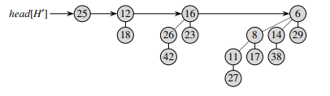
One possible configuration of a min binomial heap. The values inside the nodes may differ, provided the min-heap property is not violated; however, the structure of the binomial trees remains the same.

Q8) Answer:$3,2,1,0$
Convert 15 into binary:
15= (1111)₂ =8+4+2+1
The heap contains B₃, B₂, B₁ and B₀
Thus, the degrees in decreasing order are:
3,2,1,0

Q9) First see the union operation in binomial heap.
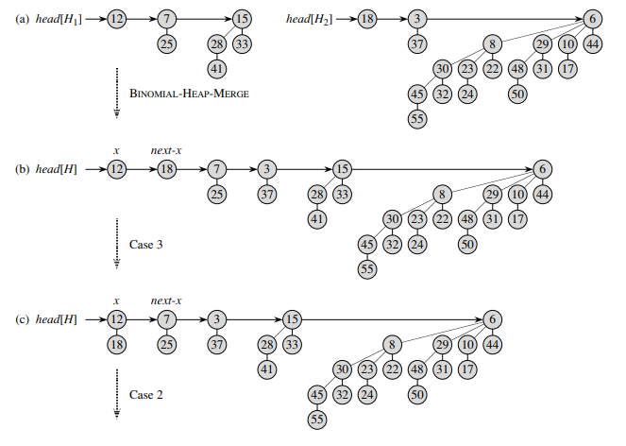

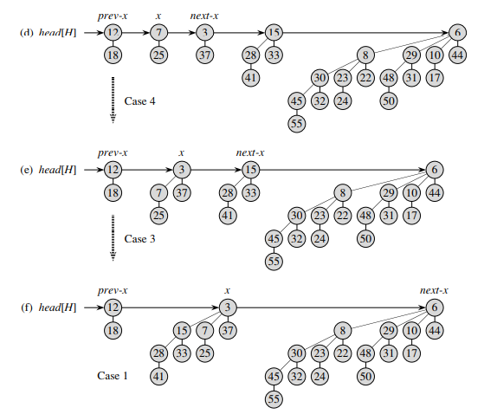

Q10) First see the extract min operation in binomial heap
